 | 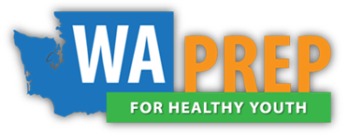 |  | WA PREP  Data Collection Checklist
School District:
Dates of Implementation:
School:
Curriculum:

Data collection materials included in the package (include quantity):
Item | Included | Quantity
Youth Entry Survey | ☐Y ☐ N
Youth Exit Survey | ☐Y ☐ N
Staff Perceptions Survey | ☐Y ☐ N
Attendance | ☐Y ☐ N

Submission Instructions
Include a data collection checklist with each submission.

For hard copies, please mail documents to:  Rebecca Wheaton, Cardea Services  1809 7th Avenue Suite 600  Seattle, WA 98101 | For electronic submissions please send to:  rwheaton@cardeaservices.org

